**What is a Quasicrystal?**

**Mathematical Foundations of Quasicrystallography**

Alexander Illarionov

Westminster School

Mathematical foundations of crystallography and quasicrystallography are qualitatively reviewed. Beginning with the generalisation of periodic structures to *n-*dimensional space, the general concept of an aperiodic crystal is investigated through modelling (Delone sets, tilings, almost periodic functions) and construction techniques. Major results and directions of research in long-range aperiodic order are outlined. Definitions of an almost periodic crystal and a quasicrystal as a quasiperiodic crystal are formalised.

Table of Contents

Introduction 2

Notation 3

I. Periodic Crystals 3

I.1 3-dimensional Crystalline Structures 3

I.2 n-Dimensional Periodic Crystals 5

II. Aperiodic Crystals 6

II.1 Modelling 7

II.1.1 Tilings 7

II.1.2 Functions 9

II.2 Construction of Aperiodic Crystals 11

II.2.1 Cut-and-Project Scheme 11

II.2.2 Substitution and Multigrid Methods 13

III. Discussion 15

III.I. Definition of Quasicrystals and Crystals 16

III.II Theoretical Frameworks of Mathematical Quasicrystallography 17

Conclusion. 20

Appendix I. Foundations 21

I. Diffraction 21

II. Delone Sets 22

Appendix II. Bravais Lattices 25

Appendix III. Example of a Nonperiodic Tiling 26

Appendix IV. Pinwheel Tiling 27

Bibliography 28

# Introduction

For many years periodicity was considered a characteristic feature of a crystalline structure. With the discovery of X-ray diffraction in 1912 and various other techniques throughout the twentieth century, the atomic model of a crystal as an ordered periodic array of atoms or groups of atoms was accepted. (Kittel 2005) Both order and periodicity served as synonymous, equivalent conditions defining the notion of a crystal. (Lifshitz, Quasicrystals: A matter of definition. 2003) However, Dan Shechtman’s discovery (Shechtman, et al. 1984) of an aluminium-manganese alloy with a five-fold rotational symmetry, incompatible with the periodicity paradigm, proved the necessity of the paradigm shift. (Lifshitz, What is a crystal? 2007)

In 1992 the definition was altered by the International Union of Crystallography through the Ad Interim Commission on Aperiodic Crystals from the microscopic description of the crystalline structure to the specific characteristics of the data obtained in a diffraction experiment, whereby a crystal is “*any solid having an essentially discrete diffraction diagram*”. (Ad Interim Commission on Aperiodic Crystals 1992) The adopted definition is purportedly vague, which is intended to eliminate unnecessary constraints until complete understanding of crystallinity and long-range order is achieved. (Lifshitz, Quasicrystals: A matter of definition. 2003)

Long-range orientational order is defined as a measure of long-range correlation between the bond angles of neighbouring atoms. (Janot 2012) In mathematical modelling of physical structures, atoms and molecules constituting the building blocks of the structure are replaced by points. Thus, point sets with long-range orientational order are completely defined by local configurations. The trivial example of a class of locally determined point sets is a class of periodic lattices modelling physical periodic crystals. A complete characterisation of point sets with long-range order plays a key role in classification of periodic and aperiodic structures. However, existence of a general constructive procedure, generating every ordered point set, both periodic and nonperiodic, is still unknown. (Lifshitz, What is a crystal? 2007)

In order to decide on the exhaustive definition of a quasicrystal and investigate periodic and aperiodic structures, the following aspects are examined in the present work:

* properties of periodic structures and their relation to aperiodicity
* modelling of periodic and aperiodic point sets and analysis of long-range order in aperiodic structures

## Notation

The Minkowski addition notation is used throughout the paper. The Minkowski sum/difference of two point sets A, B, $A, B∈E^{n}$, is defined as the set $∀(a∈A, b∈B)\{A+B≔\left\{a±b\right\}\}$. (Encyclopedia of Mathematics 2011)

B(r) is a closed ball of radius r. B(**x**; r) is a closed ball centered at x of radius r.

If $X$ is a topological space and $A⊆X,\overline{A}$ is the closure[1] of the set A.

$R^{n}$ is n-dimensional Euclidean space with the metric (a function defining the distance between the points …, )

…, 2 =

(Encyclopedia of Mathematics 2013).

***NOTE***

*For a brief outline of the background knowledge (Delone and diffraction formalism) the reader is referred to the Appendix I.*

# I. Periodic Crystals

## I.1 3-dimensional Crystalline Structures

A perfect periodic crystal is modelled as a system constructed by the infinite translation of identical groups of atoms. (Kittel 2005) The translated group is called a **basis**. The basis is attached to every point in a lattice. Every point in a three dimensional lattice has identical surroundings of equivalent points. Therefore, the crystal lattice exhibits perfect translational symmetry. Any point in a lattice can be located relative to an arbitrary origin by the position vector:

**r**= n1**a**+n2**b**+n3**c**

The numbers ni are integers and the vectors **a**, **b**, **c** are **basis vectors**. The basis vectors indicate the direction of the axes in the system of coordinates corresponding to the lattice and define the volume of a **primitive cell**, containing one lattice point. (The International Union of Crystallography 2008) The primitive cell is chosen in such a manner that there is no cell of a smaller volume constituting the building block of a lattice.

A primitive cell in a lattice may also be constructed as a polyhedron obtained by connecting a given lattice point to all neighbouring points and drawing the planes which are perpendicular to the connecting lines and pass through their midpoints (The International Union of Crystallography 2012). Thus, the locus of points in space closer to the given point than to any other point in a lattice is obtained. The minimal volume enclosed by this procedure is called a **Wigner-Seitz primitive cell**.

Non-primitive cells, also called crystallographic **unit cells**, are comprised of primitive cells. In general, the unit cell of a periodic structure represents its symmetry in a more illustrative manner, often favouring introduction of orthogonal axes into the model (Janot 2012).

It can be demonstrated that the number of distinct ways of arranging identical points in space of dimension n ≥ 1 is finite. (Encyclopedia of Mathematics 2012). A periodic array of points, determined by a certain symmetry group, is called a **Bravais lattice** (Janot 2012). There are 14 different types of Bravais lattices in a 3-dimensional space (cf. Appendix II). (Kittel 2005)

Since a basis is associated with every point in a lattice, a crystal structure is constructed by specifying a Bravais lattice and a basis. Thus, the position vector of a particular basis in the crystal structure is as follows:

**r**j= n1**a**+n2**b**+n3**c**+**R**j ,

where **R**j is a position vector of the basis relative to the lattice point. The introduction of the basis induces new symmetry elements such as rotations and reflections (Janot 2012). Rotation and reflection, or a combination of these, turns the structure into itself. A group of the corresponding symmetric operations defines a **point group**. By combining translation and point group symmetry operations in three dimensions, 230 different symmetry configurations, called **space groups**, can be obtained in total. (Encyclopedia of Mathematics 2012) Each three-dimensional periodic point set corresponds to one of the 230 space groups. (Janot 2012) By the crystallographic restriction theorem, a 2-dimensional space can be tiled periodically only by rectangular, triangular, square, or hexagonal tiles, which is also true in a 3-dimensional space (Janot 2012). 1,2,3,4,6-fold rotational symmetries are thus called **crystallographic symmetries**.

A 3-dimensional Bravais lattice may be considered as a stacking of two-dimensional planes, called **lattice planes** (Janot 2012). A lattice plane is defined as a plane containing at least three noncollinear Bravais lattice points. Due to the translational symmetry of the Bravais lattice, any lattice plane would contain infinitely many lattice points. A set of parallel, equally spaced lattice planes, containing all the points of the 3-dimensional Bravais lattice, is called a family of lattice planes (Ashcroft and Mermin 1976). The resolution of a Bravais lattice into a family of lattice planes is not unique. In fact, there is an infinite number of possible distinct resolutions due to an infinite number of combinations of three noncollinear points in the lattice.

## I.2 n-Dimensional Periodic Crystals

Three-dimensional aperiodic crystals can be described by the periodic structures of dimension greater than 3. Understanding periodic structures of dimension *n* is critical in analysis of long-range orientational order in aperiodic structures, as it is shown in the following section. In the current section periodic structures are investigated in the n-dimensional Euclidean space $E^{n}$ with orthonormal basis , [2].

Any set of vectors ${\vec{a}}_{1}, {\vec{a}}_{2}, {\vec{a}}_{3}, … , {\vec{a}}_{k}∈ E^{n}$ forms a countably infinite[3] group under addition, called a **Z-module.** The elements of the Z-module are the vectors in the following form:

$\vec{x}=n_{1} {\vec{a}}_{1}+n_{2} {\vec{a}}_{2}+n_{2} {\vec{a}}_{2}+…+n_{k} {\vec{a}}_{k} , n_{i} ∈ Z$.

Hence, a Z-module is the set of all translations of ${\vec{a}}_{1}, {\vec{a}}_{2}, {\vec{a}}_{3}, … , {\vec{a}}_{k}∈ E^{n}$. The orbit[4] of the Z-module is denoted as **Ω**.

The T-patch of $x∈$ Ω is defined as the limit of its T-patches as $r→∞$. (Senechal, Quasicrystals and Geometry 1996) Since Ω is the orbit of the translation group, all T-patches of Ω are translated copies of each other.

Every point in Ω is the point symmetry for Ω, and so is the midpoint between all $x, y ∈$ Ω. (Senechal, Quasicrystals and Geometry 1996) The first statement can be proven by considering a point $y∈$ Ω. Since all T-patches of Ω are translates of each other, it can be assumed that y = 0. Since Ω is a set of all integral linear permutations of the points of the Z-module, if $x∈$ Ω, then $-x∈$ Ω, for all $x∈$ Ω. The second part can be demonstrated constructively by considering $x, y, z∈$ Ω. Consider the midpoint $\frac{x+y}{2}$. The image of z under inversion through this midpoint is given by $z^{'}=x+y-z$, which is contained in Ω (see Fig 3).

A Z-module in $E^{n}$ is a **lattice $L$** if it is a set of n linearly independent vectors (Senechal, Quasicrystals and Geometry 1996). [5]

Any set of n linearly independent vectors spanning a corresponding lattice $L$ is called a **basis** of the lattice. Let a **rank** of a Z-module be its cardinality, or the number of vectors in the Z-module. A lattice, which basis necessarily contains n elements, is called a **full rank** lattice.



$$\frac{x+y}{2}$$

*z*

*z'*

*y*

*x*

*Fig 3. Inversion of arbitrary z through $\frac{x+y}{2}$.*

By definition, any Z-module is uniformly discrete (the packing radius is equal to half the difference between vectors of the basis such that the difference is minimal) and homogeneous (the covering radius is equal to the magnitude of the greatest basis vector). Hence, any Z-module, and thus any lattice, is a Delone set (cf. Appendix I).

A **period lattice** of a Delone set X is a lattice of translation symmetries Λx defined as

$$Λ_{x}=\left\{t∈E^{n},t≠0\right| X+t=X\}$$

Thus, if |=n, X is a lattice. (Lagarias and Pleasants 2003)

# II. Aperiodic Crystals

An aperiodic crystal was defined in 1992 as any crystal in which lattice periodicity is absent (Ad Interim Commission on Aperiodic Crystals 1992). Thus, the cardinality of a period lattice of an aperiodic crystal, |, is equal to zero.

There are two seemingly distinct ways of describing a model of a crystal, in terms of lattices, or *tilings* in general, which point decorations represent positions of atoms, and in terms of *functions*, specifying the distribution of the scattering medium. (Baake and Grimm, Mathematical diffraction of aperiodic structures 2012)

In this section, modelling of aperiodic crystals is outlined using both approaches, which is followed by the discussion of two general methods of constructing an aperiodic structure with any rotational symmetry.

## 

## II.1 Modelling

### II.1.1 Tilings

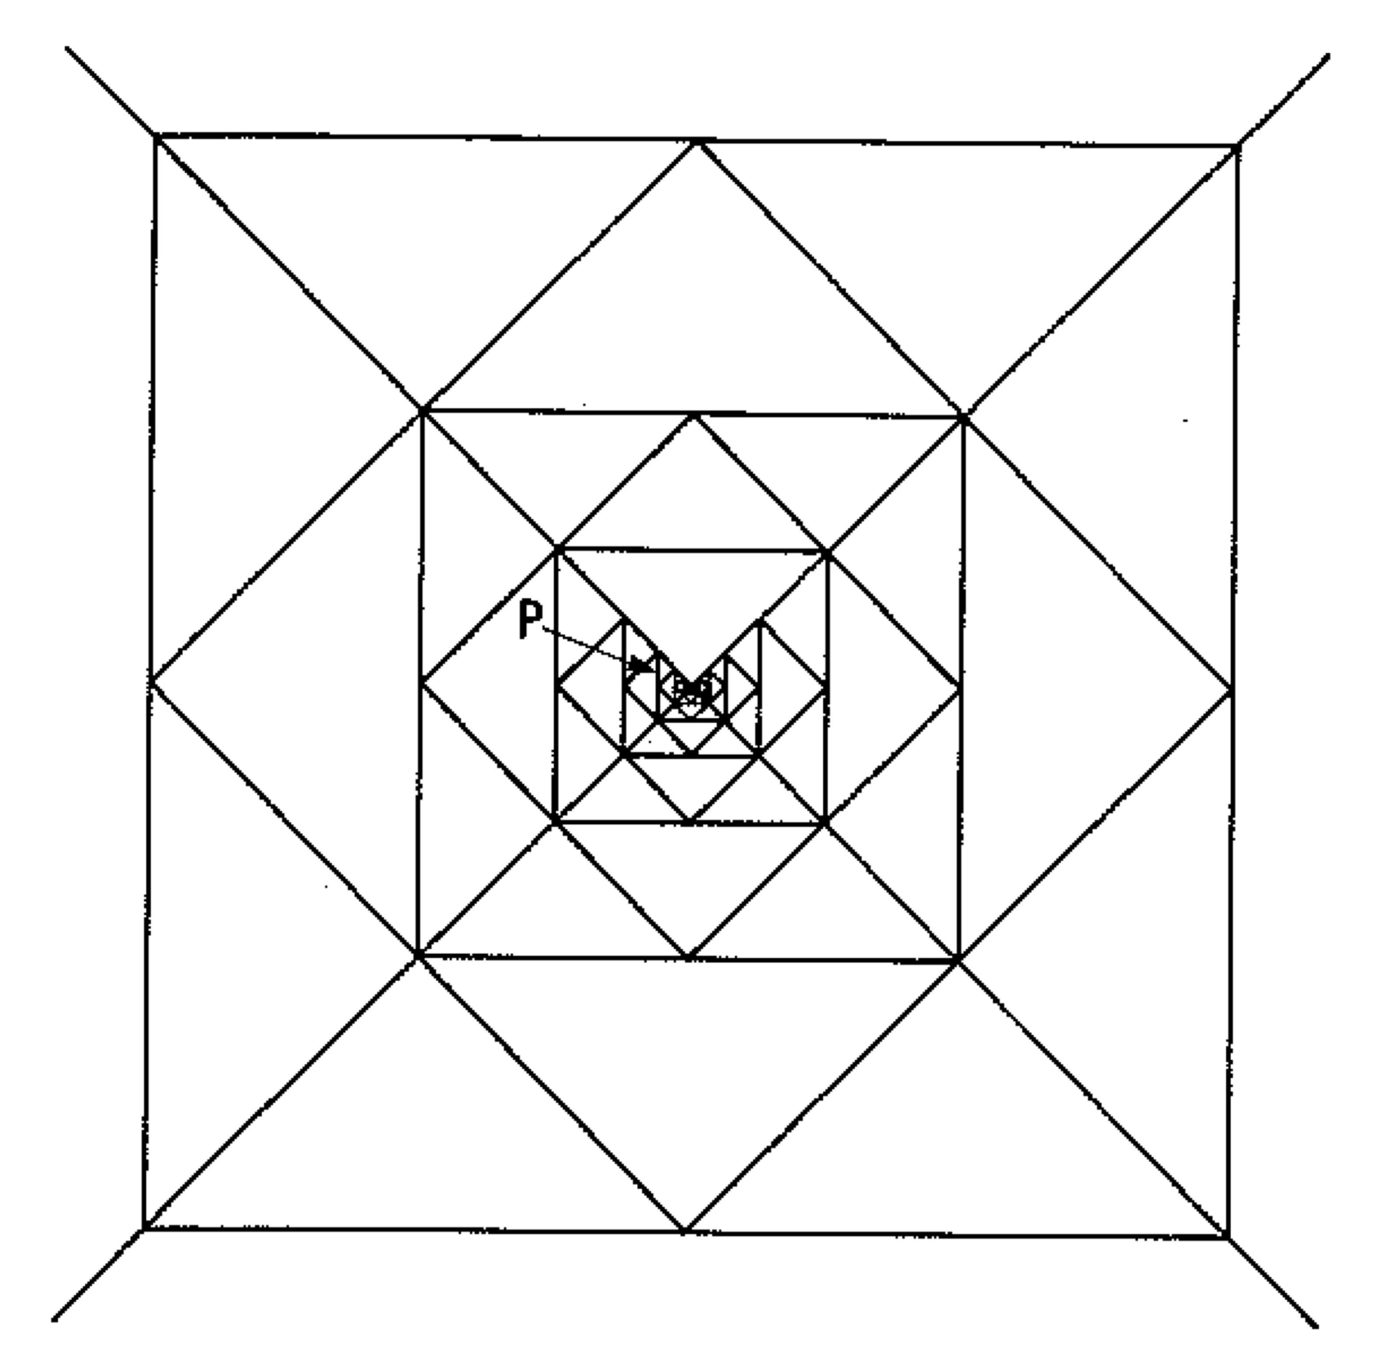 A *tiling T* of $R^{n}$ is a countable family of closed[6] sets called tiles, $T=\{T_{1}, T_{2}, T_{3}, …, T_{n}\}$, such that $∀\left(T_{i}, T_{j}∈T\right)\{T_{i}∩{int T}_{j}=∅ | i≠j\}$ and $\bigcup_{i=1}^{∞}{T_{i}}=R^{n}$, where *int* T stands for the interior of T. (Senechal, What is a Quasicrystal? 2006) Tiles span the Euclidean space without gaps or overlaps. The equivalence classes of tiles up to some restriction[7] *M* are called *prototiles.* A set *P* of class representatives is called a *protoset* of *T* with respect to *M.*

However, the definition as given allows unbounded tiles, tilings which are not locally finite[8] with so-called *singular points* forming*,* tiles with disconnectivities (‘holes’), infinite protosets and other special cases. (Grunbaum and Shephard 1986) Thus, the following conditions are imposed on a protoset *P* of a tiling *T* in $R^{n}$ for crystallographic purposes [(Senechal, Quasicrystals and Geometry 1996), (Grunbaum and Shephard 1986)]:

*Fig 4*. *A tiling with isosceles right triangles as prototiles*

P is a singular point.

*Credit:*

(Grunbaum and Shephard 1986)

1. Each prototile is homeomorphic[9] to an n-dimensional ball. Thus, each prototile is bounded and without holes.
2. The intersection of any pair of tiles is a connected[10] set, i.e. it does not consist of two distinct and disjoint parts.
3. *T* is **uniformly bounded**, i.e. there exist two positive real numbers $r_{0}$ and $R_{0}$ such that every tile contains an n-ball of radius $r_{0}$ and every tile is contained in an n-ball of radius $R_{0}$, and hence it is locally finite.

A tiling of $R^{n}$ is **periodic** if it admits translations in n linearly independent directions. If a tiling admits translations in $1<k<n$ directions, it is called **subperiodic**.

A tiling of $R^{n}$ is **nonperiodic** if it admits no translations.

A protoset is called *aperiodic* if it admits only nonperiodic tilings. A tiling of $R^{n}$ is **aperiodic** if its protoset is aperiodic. If a tiling is nonperiodic, it is not guaranteed that the tiling is also aperiodic, cf. Appendix III.

Consider a non-empty point set X. The **Voronoi domain** of a point $p∈X$ is defined as follows (Baake and Grimm, Aperiodic Order: Volume 1 , A Mathematical Invitation 2013):

$$V\left(p\right)=∀\left(x∈R^{n}, q∈X\right)$$

$\{\left|x-p\right|≤\left|x-q\right|\}$.

That is, the Voronoi domain of a point p is a set of all points of $E^{n}$ which are not closer to any other point q of X than to p [11]. (Schlottmann, Periodic and Quasi-Periodic Laguerre Tilings 1993) A *marked* Voronoi domain is a Voronoi domain together with a corresponding point considered as marked. The set of Voronoi domains comprise a tiling of $E^{n}$ called the **Voronoi tessellation** of $R^{n}$ induced by X. A *marked* Voronoi tessellation includes a Voronoi tessellation with the points of X marked. (J. Lagarias, Geometric Models for Quasicrystals I. Delone Sets of Finite Type 1999)

Let the concept of a Delone set of finite type be introduced, which was first formulated by J. Lagarias in 1999. A Delone set Λ is **of finite type** if for all T

$B\left(0; T\right)∩Λ-Λ$ is finite, i.e., any closed ball intersecting with $Λ-Λ$ contains finitely many points of $Λ-Λ$. A Delone set Λ is said to be **finitely generated** if for all $x,y∈Λ$ the abelian group under the vector addition operation

$\left[Λ-Λ\right]=Z[x-y]$ is finitely generated[12],[13]. J. Lagarias (1999) has shown that all Delone sets of finite type are finitely generated. Furthermore, for a Delone set Λ in $E^{n}$ the following conditions can be shown to be equivalent:

1. Λ is a Delone set of finite type.
2. Λ has FLC[14] up to translations.
3. The marked Voronoi tessellation of $R^{n}$ induced by Λ contains finitely many translation-equivalence classes of marked Voronoi domains.

Assume there is a tiling of $R^{n}$; thus, there exists a set of prototiles filling the space without gaps or overlaps. Each prototile can be decorated by a finite number of points indicating, for instance, the atomic positions of a crystal. By this procedure a Delone set (r, R) is generated, since the packing radius r is determined by the minimal distance between two points lying on one of the prototiles, while the covering radius R is defined by the maximum distance between two points corresponding to some prototile.

Assume a Delone set Λ is given. Hence Voronoi domains and thus the Voronoi tessellation can be constructed. If Λ is of finite type, by the property (iii) the number of Voronoi domains, or prototiles of the Voronoi tessellation, is finite.

Hence, tilings are equivalent to Delone sets in modelling of aperiodic crystals in the sense that one can be obtained from the other by following a constructive procedure.

### II.1.2 Functions

As described in the Appendix I.I, a crystalline structure is experimentally determined by analysis of a diffraction experiment; a diffraction pattern is obtained. If the scattering medium exhibits long-range order, the diffraction pattern has a defined discrete component with sharp Bragg peaks corresponding to a particular angle formed by the source of radiation and the medium. The amplitude of the light incident on the detector in case of kinematic Fraunhofer diffraction is the Fourier transform of the *density function*, which determines the distribution of the scattering medium. (Phillips 2011)

One of the important tools in the study of aperiodic structures, which was investigated by Harald Bohr (1947), is the theory of *almost periodic functions*. A continuous function $f$ is called **uniformly almost periodic** on $R^{n}$ if for any $ε>0$ there exists a relatively dense set of vectors $τ∈R^{n}$ such that[15]

.

Bohr has shown that an almost periodic function, akin to periodic functions, can be expanded in a generalised Fourier series (Senechal, Quasicrystals and Geometry 1996). Moreover, the following relation between periodic and almost periodic functions can be proven. Consider a uniformly convergent series of continuous periodic functions $\{ f_{k} \}$, where $k∈N$. A function $f$ is called **limit periodic** if it is the limit of $\{ f_{k} \}$. Define a diagonal[16] function

$g\left(x\right)=f(x,x,x,…,x,…\}$.

It can be shown that $g$ is an almost periodic function (Besicovitch 1954). Thus, any uniformly almost periodic function $g$ is the diagonal function of a limit periodic function $f$ of a finite or infinite number of variables. (Catto, Le Bris and Lions 1998)

Each periodic function is uniformly almost periodic, and the coefficient of the generalised Fourier series reduces to the ordinary Fourier coefficient. In general, there are at most countably many pairwise incommensurate[17] fundamental frequencies in the generalised Fourier series. If the number of fundamental frequencies is finite, the series represents a *quasiperiodic* function. (Baake and Grimm, Aperiodic Order: Volume 1 , A Mathematical Invitation 2013)

Suppose there is a smooth[18] periodic function $f$ in $R^{n}$. If $f$ is restricted to the subspace of $R^{n}$, an almost periodic function is obtained. Consider then the Fourier series expansion of $f$. The Fourier coefficients decrease rapidly as the wave vector moves further from the origin. Thus, only finitely many Fourier coefficients corresponding to the sinusoids in the Fourier series have a significant value in the approximation of $f$. Hence, only finitely many sinusoids approximating the almost periodic function, obtained by restriction of $f$ to the subspace of $R^{n}$, are significant. The corresponding points of the Fourier transform form a finite point set, which is a bounded[19] projection of the Z-module in $R^{n}$ on the subspace of $R^{n}$, from which the infinite model of an aperiodic structure can be extrapolated. (Arnold 2004)

## II.2 Construction of Aperiodic Crystals

### II.2.1 Cut-and-Project Scheme

The projection method of generating an almost periodic function can be formalised and generalised through the concepts of *Meyer* and *model* sets.

A point set is defined as a **Meyer set** if Λ is homogeneous and $Λ-Λ$ is uniformly discrete[20]. (Baake and Grimm, Aperiodic Order: Volume 1 , A Mathematical Invitation 2013) Uniform discreteness of $Λ-Λ$ implies uniform discreteness of Λ, since if there exists a packing radius for all the differences between the points of Λ, then the packing radius exists for Λ itself. A Meyer set can be equivalently defined as a Delone set such that $Λ-Λ⊆ Λ+F$ for some finite set F. (J. Lagarias, Meyer's Concept of Quasicrystal and Quasiregular Sets 1996) Moreover, adding or removing a finite set of points from a Meyer set does not destroy the Meyer property of the set. (Moody, Long-range order and diffraction 2006)

Meyer sets can be characterised in terms of *cut-and-project* sets (J. Lagarias, Geometric Models for Quasicrystals I. Delone Sets of Finite Type 1999). Consider a full rank lattice Λ in $R^{d}=R^{n+m}=R^{n}×R^{m}$, which is called the *embedding space* of Λ. Let $π^{∥}$ be an orthogonal projection onto $R^{n}$, which is called the *physical* space, and let $π^{⊥}$ be an orthogonal projection onto $R^{m}$, which is called the *internal* space. A *window $Ω$* is a relatively compact[21] subset of $R^{m}$ with non-empty interior. The *strip $S(Ω)$* in $R^{d}$ corresponding to the window $Ω$ is defined as follows:

|

The **cut-and-project set** X(Λ, Ω) associated to the lattice Λ and the window Ω is $X\left(Λ,Ω\right)=π^{∥}(Λ∩S\left(Ω\right))$. A cut-and-project set is *nondegenerate*, if

$π^{∥}: R^{d}→R^{n}$ is one-to-one on Λ, i.e. $Λ∩\left(\left\{0\right\}×R^{m}\right)=\{0, 0\}$. A cut-and-project set is *irreducible* if $X\left(Λ,Ω\right)$ is nondegenerate and $π^{⊥}(Λ)$ is dense[22] in . An irreducible cut-and-project coincides with the concept of a *model* set.

Model sets are a generalisation of cut-and-project sets to the embedding space $R^{d}×H$, where *H* is a locally compact abelian group[23]. A *cut-and-project scheme* is a triple $\left(R^{d}, H, L\right)$ with a locally compact abelian group *H*, a lattice *L* in $R^{d}×H$ and two orthogonal projections $π^{∥}: R^{d}×H → R^{d}$ and $π^{⊥}:R^{d}×H→H$ such that restriction of $π^{∥}$ to *L* is one-to-one and $π^{⊥}\left(L\right)$ is dense in H. (Baake and Grimm, Aperiodic Order: Volume 1 , A Mathematical Invitation 2013) Consider a cut-and-project scheme $\left(R^{d}, H, L\right)$. If $Ω⊂H$ is a relatively compact set with non-empty interior (also called a *window* or an *acceptance domain*), a set | }, or any translate $t+M(Ω)$, where $t∈R^{d}$, is called a **model set**. Injection of $π^{∥}$ restricted to L guarantees the lack of a period lattice of any model set. (Moody, Model Sets: A Survey 2000)

It can be shown that a model set thus defined is Meyer. Moreover, Meyer has proven that a Delone set Λ is Meyer if and only if there exists a model set X containing Λ as a relatively dense subset, see [ (Moody, Meyer sets and their duals 1997), (Meyer 1972)].

From the physical point of view, model sets exhibit an advantageous property of a well-defined and uniform density (Schlottmann, Cut-and-project sets in locally compact abelian groups 1998). Thus, the number of points in an arbitrary chosen volume is characteristic of the number of points in the infinite limit volume, and the limit is independent of the relative position of the volume under consideration. This property is important, since experiments are conducted with finite samples, which can then be analysed to accurately approximate the general crystalline structure. Moreover, it can be shown (Schlottmann, Cut-and-project sets in locally compact abelian groups 1998) that the density of a model set is proportional to the volume of the acceptance domain and can be readily calculated by following a well-defined procedure.

### II.2.2 Substitution and Multigrid Methods

One of the objectives of crystallography is to investigate growth mechanisms of aperiodic crystals. If an aperiodic crystal is assumed to be comprised of a finite number of stable atomic clusters, and the interactions between the clusters force nonperiodicity, then these clusters of atoms can be represented as decorations of a finite set of prototiles subjected to well-defined *matching rules*.

A finite set of **matching rules** is a set of restrictions on which tiles can be adjacent to each other and how they can be relatively positioned. A tiling *satisfies* a set of matching rules if and only if each pair of adjacent tiles is permitted under matching rules. (Goodman-Strauss, Matching Rules and Substitution Tilings 1998) Thus, given a configuration of tiles satisfying a set of matching rules, the tiling can be constructed using only locally defined conditions.

A tiling is said to be *hierarchical* if its tiles can be merged, or composed, to form a new tiling with a finite protoset ‘on a larger scale’, and then these tiles can be composed to form another tiling with a finite protoset, and so on *ad infinitum.* If the tiles of the larger-scale tiling are similar copies of the smaller copies and the composition matrix is primitive[24], then such a tiling is called a **substitution tiling**. A tiling is called **uniquely hierarchical** if its n-level tiles can be composed into (n+1)-level tiles in only one way for all $n∈\{0\}∪N$. It can be shown that a uniquely hierarchical tiling is nonperiodic. (Senechal, Quasicrystals and Geometry 1996)

Goodman-Straus (1998) has proven the following result:

*Every substitution tiling of $R^{n}, n>1$, can be enforced by a finite set of matching rules, provided the tiles admit a set of hereditary edges such that the substitution tiling is sibling-edge-to-edge.*

That is, if there exist vertices and edges for the tiles under consideration such that the vertices/edges of the ‘parent’ tiles coincide with those of the ‘children’ and the vertices/edges of the ‘sibling’ (children) tiles coincide, a finite set of matching rules can be imposed on the tiling. (Goodman-Strauss, Aperiodic Hierarchical Tilings 1999) For a classical example of a nonperiodic substitution tiling, see Appendix IV.

Another method of constructing nonperiodic tilings is the *multigrid* method introduced by de Bruijn in 1981 for the study of the Penrose tilings, which can be generalised to construct nonperiodic tilings in $R^{n}$ with n-parallelotopes as prototiles. (de Bruijn 1981)

Consider a Penrose tiling in two dimensions depicted in Fig. 5. Observe that parallelograms sharing parallel edges form well-defined classes, or infinite ‘chains’, of parallelograms. By constructing lines orthogonal to the corresponding edges of parallelograms, a configuration of superposed lines is obtained consisting of *k* families of parallel lines, where *k* is the number of distinct directions of edges. If this configuration is orthogonally dual[25] to the tilings of rhombi, the tiling is uniquely determined. (Senechal, What is a Quasicrystal? 2006)

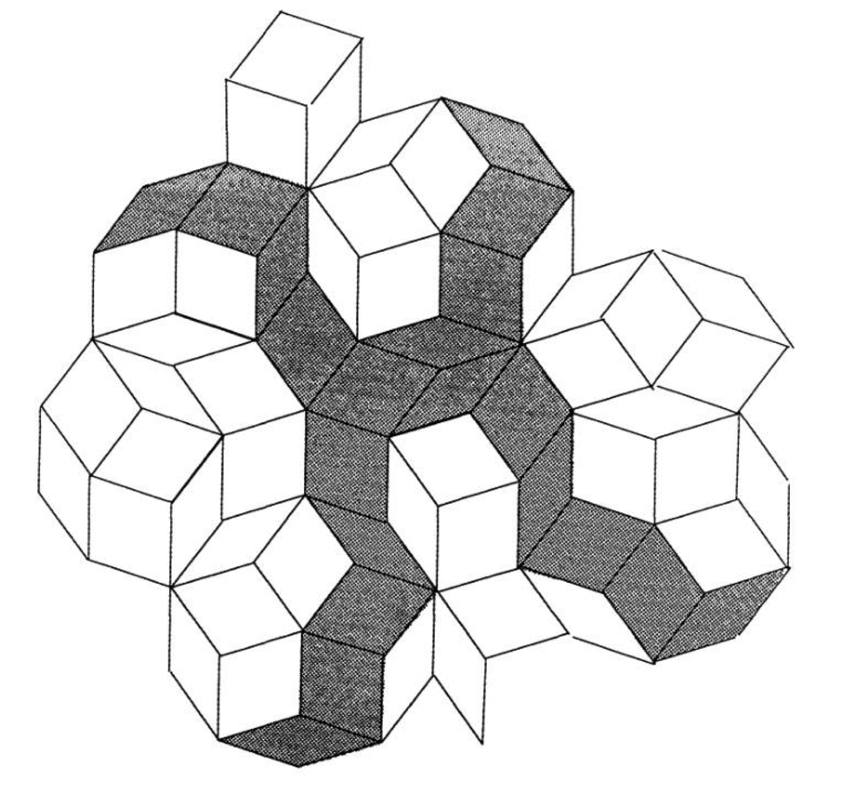

*Fig 5*. *A Penrose tiling with two classes of parallelograms indicated.*

*Credit:* (Senechal, Quasicrystals and Geometry 1996)

For certain tilings of $R^{n}$, the subspace configuration can be realised as the superposition of families of orthogonally equidistant hyperplanes[26]. Thus, a **grid** in $R^{n}$ is defined as an infinite set of parallel hyperplanes with a fixed interplanar distance *d*; a vector of length *d* orthogonal to the hyperplanes is called a *grid vector*. A **multigrid,** or **k-grid**, is a superposition of *k* grids; the corresponding set of *k* grid vectors is the star of the multigrid.

The multigrid method reverses the process of tiling dualisation. The multigrid method can be generalised to construct a tiling in $R^{n}$ as follows (Senechal, What is a Quasicrystal? 2006):

1. Choose a set of *k* linearly independent unit vectors, $k>n$, which are called *grid vectors*, such that the grid vectors span $R^{n}$.
2. Superimpose *k* grids orthogonal to the grid vectors of choice in such a way that any *n* hyperplanes intersect in a point only. If more than *n* hyperplanes intersect at any point, shift sufficiently many grids in the direction of their grid vectors in such a way that no point of intersection of more than *n* hyperplanes exist.
3. Construct the prototiles of the multigrid tiling by considering the points of intersection of hyperplanes. The prototile corresponding to the point of intersection is the parallelotope spanned by the grid vectors corresponding to the intersecting hyperplanes. The number of prototiles is finite up to translation, since there are $\left({k \atop n}\right)$ possible combinations of intersecting hyperplanes.
4. By following the matching rules imposed by the grids and using copies of the prototiles, construct an orthogonal dual of the multigrid. The dual obtained is a tiling, which has been shown, for instance, by de Brujin (1986).

The shifts in the step 2 are necessary to eschew ‘singular’ cases. If $l$ hyperplanes intersect, the polytope formed by the procedure described in the step 3 is a 2*l-*gon. The restrictions imposed on the multigrid guarantee that the points of intersection correspond to the vertices of the parallelotope covering of $R^{n}$ such that every point of $R^{n}$ belongs to exactly one of the parallelotopes which includes some parts of its boundary. Since all the grid vectors have the same magnitude, all the parallelotopes are rhombohedra. (De Bruijn 1986) It can be shown that the tiling thus obtained can be alternatively constructed by a cut-and-project method. Moreover, since $k$ is strictly greater than n by definition and the grid vectors are linearly independent, the tiling is nonperiodic. (Gahler and Rhyner 1985)

# III. Discussion

Although more than three decades have passed since the discovery of a physical quasicrystal by Shechtman *et al.*, there are a lot of queries to be answered and conundrums to solve. The following list is a modicum of the ensuing questions:

1. A. What is *the* accurate and precise definition of a crystal? What is *the* definition of a quasicrystal?

B. Hence what are the appropriate theoretical frameworks for crystals and quasicrystals?

1. What is the formal theory of long-range periodic and aperiodic order?
2. How can the tiling theory be formalised? More specifically, how can the theory of matching rules, substitutions and multigrids be rigorously substantiated?

The first question is discussed in this section.

## III.I. Definition of Quasicrystals and Crystals

The term *quasicrystal* has been introduced as a portmanteau for a quasiperiodic crystal by Levine and Steinhardt (1984). However, what *is* a crystal? The definition declared by the Commission on Aperiodic Crystals in 1992 relies on the result of a diffraction experiment and a vague notion of ‘*essential discreteness’* of a diffraction pattern. But how can diffraction of point sets be formalised?

This question was addressed by Hof (1995). To begin with, a discrete point set Λ is representable by the sum of Dirac deltas assigned to each of its points, which is called a *Dirac comb* (Senechal, Mapping the aperiodic landscape, 1982–2007 2008):

$$ρ=\sum_{x∈Λ}{δ_{x}}$$

This procedure can be intuitively understood as encoding the information of the point set configuration by zeroes and ones; if a point is in the set, the Dirac delta thus defined outputs 1, otherwise the output is equal to zero. Every Dirac comb has a well-defined *autocorrelation measure* or several of them. An autocorrelation measure is a tool to quantify the correlation between different parts of the structure. In other words, autocorrelation measure represents a diffracting medium and stores information about the sites that would cause the incoming radiation to interfere constructively in the diffraction experiment. If an autocorrelation measure of a Dirac comb is unique, the corresponding point set is called *diffractive,* and the autocorrelation measure is denoted as $γ_{Λ}$. The Fourier transform of the unique autocorrelation measure $\hat{γ_{Λ}}$ is the *diffraction measure* of the point set, which agrees with the information obtained from the diffraction pattern. The diffraction measure can be decomposed into discrete and continuous parts. The discrete component corresponds to the character of Bragg peaks in the diffraction diagram. The condition of essential discreteness then can be formulated in terms of the discrete component of the diffraction measure. Namely, it can be reduced to the requirement that the discrete component of the crystalline diffraction measure is not equal to zero. If the diffraction measure consists of a discrete component only, the corresponding point set is called *pure point diffractive.*

But what is quasiperiodicity? Following the theory of almost periodic functions outlined in the section II.1.2, an *almost periodic* *point set* is a point set whose distribution can be expanded as a superposition of a countable number of plane waves. (Lifshitz, What is a crystal? 2007) Analogously, a diffractive point set is *quasiperiodic* if a finite number of wave vectors corresponding to the plane waves can span the entire point set. In these words, an *almost periodic crystal* is an almost periodic point set with the nonzero discrete component of the diffraction measure. A diffraction pattern of a *quasiperiodic crystal* contains Bragg peaks which can be indexed by *D* integers corresponding to the number of families of parallel plane waves in the expansion of the distribution, i.e. to the rank of the distribution. It follows that periodic crystals (as well as subperiodic and aperiodic structures) in $R^{n}$ form a subset of quasiperiodic crystals, or *quasicrystals* for short, when *D* is equal to to *n*. It is worth noting that there exist almost periodic crystals that are not quasiperiodic. (Baake, Moody and Schlottmann, Limit-(quasi)periodic point sets as quasicrystals with p-adic internal spaces 1998) Crystals of this type, called *limit-periodic* or *limit-quasiperiodic*, can be constructed as limit cases of periodic or quasiperiodic functions. If the limit satisfying certain restrictions is chosen, the resulting crystals are diffractive, despite the fact that their ranks are infinite.

Two trivial types of quasicrystals, *incommensurately modulated* and *incommensurately composite* crystals, were known before the discovery of Shechtman. An incommensurately modulated crystal is a periodically distorted (modulated) periodic crystal. The period of modulation is incommensurate with the basis period of the underlying periodic crystal (Chapuis and Arakcheeva 2013). The second is a system of two or more interpenetrating subsystems with incommensurate periods. Considered independently, each subsystem is a modulated structure, with basis structures being mutually incommensurate. (The International Union of Crystallography 2012) Both incommensurately modulated and incommensurately composite crystals can be viewed as modified periodic structures and analysed appropriately.

## III.II Theoretical Frameworks of Mathematical Quasicrystallography

The following methods of constructing ordered structures were outlined in the paper:

* Cut-and-project
* Multigrid
* Substitution
* Matching rules

It was noted that:

1. multigrid method is a special case of the projection approach
2. matching rules can be assigned to all substitution tilings

One of the important tools in describing long-ordered structures is the concept of a Delone set. Model sets, which under the condition of regularity are nonperiodic and pure point diffractive, are Delone, and comprise a large class of known quasicrystals. Lee (2007) has shown that if a substitution tiling is pure point diffractive, then the points corresponding to the vertices of the tiles also form a model set.

However, not only Delone sets provide a theoretical framework for almost periodical crystals. An example of a pure point diffractive point set in $R^{n}$, where $n≥2$, which is not Delone, is the set of *visible points* of an n-lattice, comprising holes of unbounded radius. (Baake, Moody and Pleasants, Diffraction from visible lattice points and kth power free integers 2000) An example of the set of the visible lattice points in $R^{2}$ is shown in the figure 6.

A set of visible lattice points in $R^{n}$ is a set of points with coprime coordinates in a given lattice basis. The points are called *visible* due to the fact that, given a lattice *L,* the line segment joining the arbitrary origin $x, x∈L,$ and other points with coprime coordinates contains no other points of *L*. The set of visible points is uniformly discrete, but not relatively dense. More specifically, for an arbitrary large positive real number *D*, there exists a lattice of holes of inner diameter at least *D*. (Baake and Grimm, Aperiodic Order: Volume 1 , A Mathematical Invitation 2013) It can be proven that any set of lattice visible points in $R^{n}, n≥2,$ is pure point diffractive and hence, provided it can be shown that the number of generating plane wave vectors is countable, is an almost periodic crystal.



*Fig 6. A central square-shaped patch of the visible points corresponding to the square lattice*

*Credit:* (Baake and Grimm, Aperiodic Order: Volume 1 , A Mathematical Invitation 2013)

Another special case in mathematical quasicrystallography is a pinwheel tiling, which has already been introduced in the section II.2.2 and Appendix IV. Pinwheel tilings were first extensively studied by Conway and Radin in 1994, see (Radin 1994). The classical pinwheel tiling is constructed by an inflation of a right triangle with sides 1 and 2 as a prototile with a linear scaling factor of $\sqrt{5}$ and a rotation by an angle $θ=-arctan⁡(\frac{1}{2})$, followed by a dissection into five congruent triangles, two of the same and three of the different chirality, or ‘handedness’. The rotation leaves the original tile, with which the construction is started, in the invariant position. It can be shown that $θ$ is irrational and hence in the limit the tiling contains the copies of the original prototile in the countable infinity of distinct orientations, and thus the set of all available directions of the vertex corresponding to the point of intersection of the leg of length 1 and the hypotenuse of the generating right triangle lies densely on the unit circle. Hence, if Λ is a point set of vertices of the tiles, $Λ-Λ$ is not discrete. Nevertheless, the diffraction measure of the classical pinwheel tiling contains a discrete component in the form of sharp rings (Grimm and Deng 2011). Since there is a countable infinity of the prototile directions, it is conjectured that a pinwheel tiling is an almost periodic crystal.

Some authors [ (Senechal, What is a Quasicrystal? 2006), (Tilley 2006), (Strungaru 2015)] constrain the definition of a ‘quasicrystal’ by requiring the presence of the symmetries not allowed by the crystallographic restriction theorem, called noncrystallographic symmetries, to which rotations other than 1,2, 3, 4, and 6 belong (The International Union of Crystallography 2013). In this case, the term *quasicrystal* stands for aperiodic crystals. This restriction however is not necessary in view of the existence of the cut-and-project and generalised multigrid methods to produce pure point diffractive nonperiodic tilings and aperiodic point sets of any rotational symmetry.

# Conclusion.

A *quasicrystal* is an abbreviation for a *quasiperiodic crystal*. A quasiperiodic crystal is defined as a diffractive point set determined by a superposition of a countable number of plane waves defined by a finite set of wave vectors. Quasiperiodic crystals form a subset of almost periodic crystals, for which the requirement of a finite generating set is omitted. Periodic crystals are thus by definition also quasiperiodic.

The requirement of noncrystallographic rotation symmetries in quasicrystals, which is often imposed on the quasiperiodic crystals, is superfluous and should be abolished. The known methods of construction allow creation of almost periodic crystals, and quasicrystals in particular, of any rotational symmetry.

Although research on long-range aperiodic order is extensive, no exhaustive systematic treatment of the subject matter exists. More specifically, the rigorous theory unifying point sets and tilings and their methods of construction is absent. Although there are constructive procedures warranting the equivalence of point sets described in terms of functions and tilings subject to specific conditions, functional and tiling approaches are contradictory in the sense that each model has a metric topology with a notion of closeness incompatible with the other. Both methods can be embedded into the more general concept. One of the most plausible approaches suggested is to introduce the notion of *measures*, which quantify space distributions, see (Baake and Grimm, Kinematic diffraction from a mathematical viewpoint 2011), (Baake and Grimm, Mathematical diffraction of aperiodic structures 2012). Almost periodic functions and tilings are included in the concept of a measure as special cases.

# Appendix I. Foundations

## I. Diffraction

Symmetries of physical crystal structures are determined by analysis of diffraction diagrams produced by the atoms acting as a diffraction grating. The probing radiation is required to have the wavelength comparable to the interatomic distance in order to penetrate the material deep enough. The intensity distribution is thus obtained by illuminating the crystalline sample with electrons, X-rays, or neutrons, which have the same order of wavelength as the average interatomic distance of a few angstroms. (Sólyom 2010)

The basis for diffraction analysis lies in the interference of rays *elastically[27]* scattered from different atoms in the crystal. The sample is irradiated by a collimated beam of monochromatic rays. (Janot 2012) The incident radiation is scattered by each atom with the intensity dependent on the nature of a crystal. The phase differences between the scattered rays depend on the position of the atom in the sample and the direction of the incident and scattered waves. (Sólyom 2010) Let the wavelength of the radiation be λ, the unit vector of the incident beam be **n** and the unit vector of the scattered wave be **n’**. Choosing one of the two atoms under consideration as the origin let the position vector of the other be **Rn**. The wave vector **k** of the incident ray is thus $k=\frac{2π}{λ}n$ and the wave vector of the scattered beam is $k'=\frac{2π}{λ}n'$**.**



*Fig. 1. A configuration of 2 atoms scattering incident waves*

*Credit:* (Sólyom 2010)

Therefore, the path difference is $Δs=|R_{n}\left(n-n^{'}\right)|$, and the corresponding phase difference is $Δϕ=|R_{n}\left(k-k^{'}\right)|$. The waves interfere constructively, if the phase difference is the integral multiple of 2π. Hence, the condition for the constructive interference between the diffracted beams is given by

$∀R_{n}\left[R_{n}\left(k-k^{'}\right)=2πm \right| m∈Z]$. (1)

Provided there is a sufficient number of scatterers, the intensities of the resultant beam incident on the detector (e.g. photosensitive plates) for **n** and **n’** satisfying or almost satisfying the condition (1) would be the greatest, and the intensity graph would show characteristic **Bragg peaks**.

## II. Delone Sets

Perfect physical crystals remain perfect, if the entropy of the system in which they are contained is zero. According to the third law of thermodynamics, perfect crystals do not exist in practice. This fact is neglected in the mathematical modeling of a crystal by reference to a set of geometrical points called a **point set**.

In 1930, the mathematician B.N. Delone together with his students and colleagues embarked on the formalisation of crystallography and reconstruction of fundamental concepts from first principles, including a primary notion of a point. (Senechal, Quasicrystals and Geometry 1996) A **singleton** **set** is a set consisting of one point, and a **point** **set** is a countable union of singleton sets. (Baake and Grimm, Aperiodic Order: Volume 1 , A Mathematical Invitation 2013) The postulates imposed on the *“crystalline”* Euclidean space include the property of **discreteness** and **homogeneity**. (Delone, Aleksandrov and Padurov 1934) The point sets satisfying these conditions are called **Delone sets**. No other constraints, such as symmetry considerations or periodicity of the point set, are inflicted. The mathematical description of the postulates, given by M.Senechal (1996), is the following:

1. The point set $Λ⊂R^{n}$ is **uniformly discrete** if there exists a positive real number r such that an open[28] ball B( with radius r contains at most one point $x∈Λ$. Thus, if Λ is discrete, it is locally finite, and hence for every ball *B(x, r’)* with radius *r’* > r and centre

$x ∈ R^{n}, B(x, r')∩Λ$ is a finite set. $r$ is the maximal *packing radius* of the spheres, centered at the points of the point set, packing Λ . (J. Lagarias, Geometric Models for Quasicrystals I. Delone Sets of Finite Type 1999)

1. The point set $Λ⊂R^{n}$ is **homogeneous**, or **relatively dense**, if there exists a positive real number R such that every closed ball *B(R)* with radius R contains at least one point of Λ in its interior. The constant R is called the *covering radius* of Λ, which is the minimal radius to cover $R^{n}$ with equal spheres centered at the points of Λ. (J. Lagarias, Geometric Models for Quasicrystals I. Delone Sets of Finite Type 1999)

A Delone set is also called a (r, R)-system, where r is the packing radius of the point set Λ, and R is the covering radius of Λ. (Dolbilin 1978)

Ergo, the point set Λ is a Delone set if and only if it is homogenous and uniformly discrete:

$∃(r∈ R, r>0)∀(x, y ∈ Λ)(\left| x-y\right|≥r)$

$∃(R∈ R, R>0)(|B(R)∩Λ)|≥1)$

The requirement of uniform discreteness can be justified by the physical limit of the feasible interatomic spacing. The centers of the atoms of any gaseous, liquid and solid matter cannot come arbitrarily close together. Moreover, atoms tend to be distributed uniformly through space, which is modelled by the property of point set homogeneity. Therefore, Delone sets can be utilised to model various physical structures, from highly chaotic to highly ordered. (Senechal, Quasicrystals and Geometry 1996)

The measure of complexity of a Delone set is based on the configuration of its local structure. (Lagarias and Pleasants 2003) The local structure can be characterised by ‘circular’ configurations, or **T-patches**. (Senechal, Quasicrystals and Geometry 1996)The **T-patch TΛ(x, T)** at $x∈Λ$ is the finite point set $B\left(x; T\right)∩Λ$ for r > 0.

The **T-atlas $A_{Λ}\left(T\right)$**  of Λ is defined as a set of all T-patches translated to the origin (Lagarias and Pleasants 2003):

$$A_{Λ}\left(T\right)=\left\{T_{Λ}\left(x,r\right)-x \right| x∈ Λ\}$$

The T-atlas $A_{Λ}$ of Λ is the union of all T-atlases for T > 0. The **patch counting function $N_{X}^{*}(T)$** counts the number of distinct T-patches in X up to translation equivalence, thus

$$N_{X}^{*}\left(T\right)=|A_{Λ}\left(T\right)|$$

A Delone set has **finite local complexity (FLC)** up to translations if $N_{X}^{*}\left(T\right)$ is finite for all $T>0$. (Baake and Grimm, Aperiodic Order: Volume 1 , A Mathematical Invitation 2013)

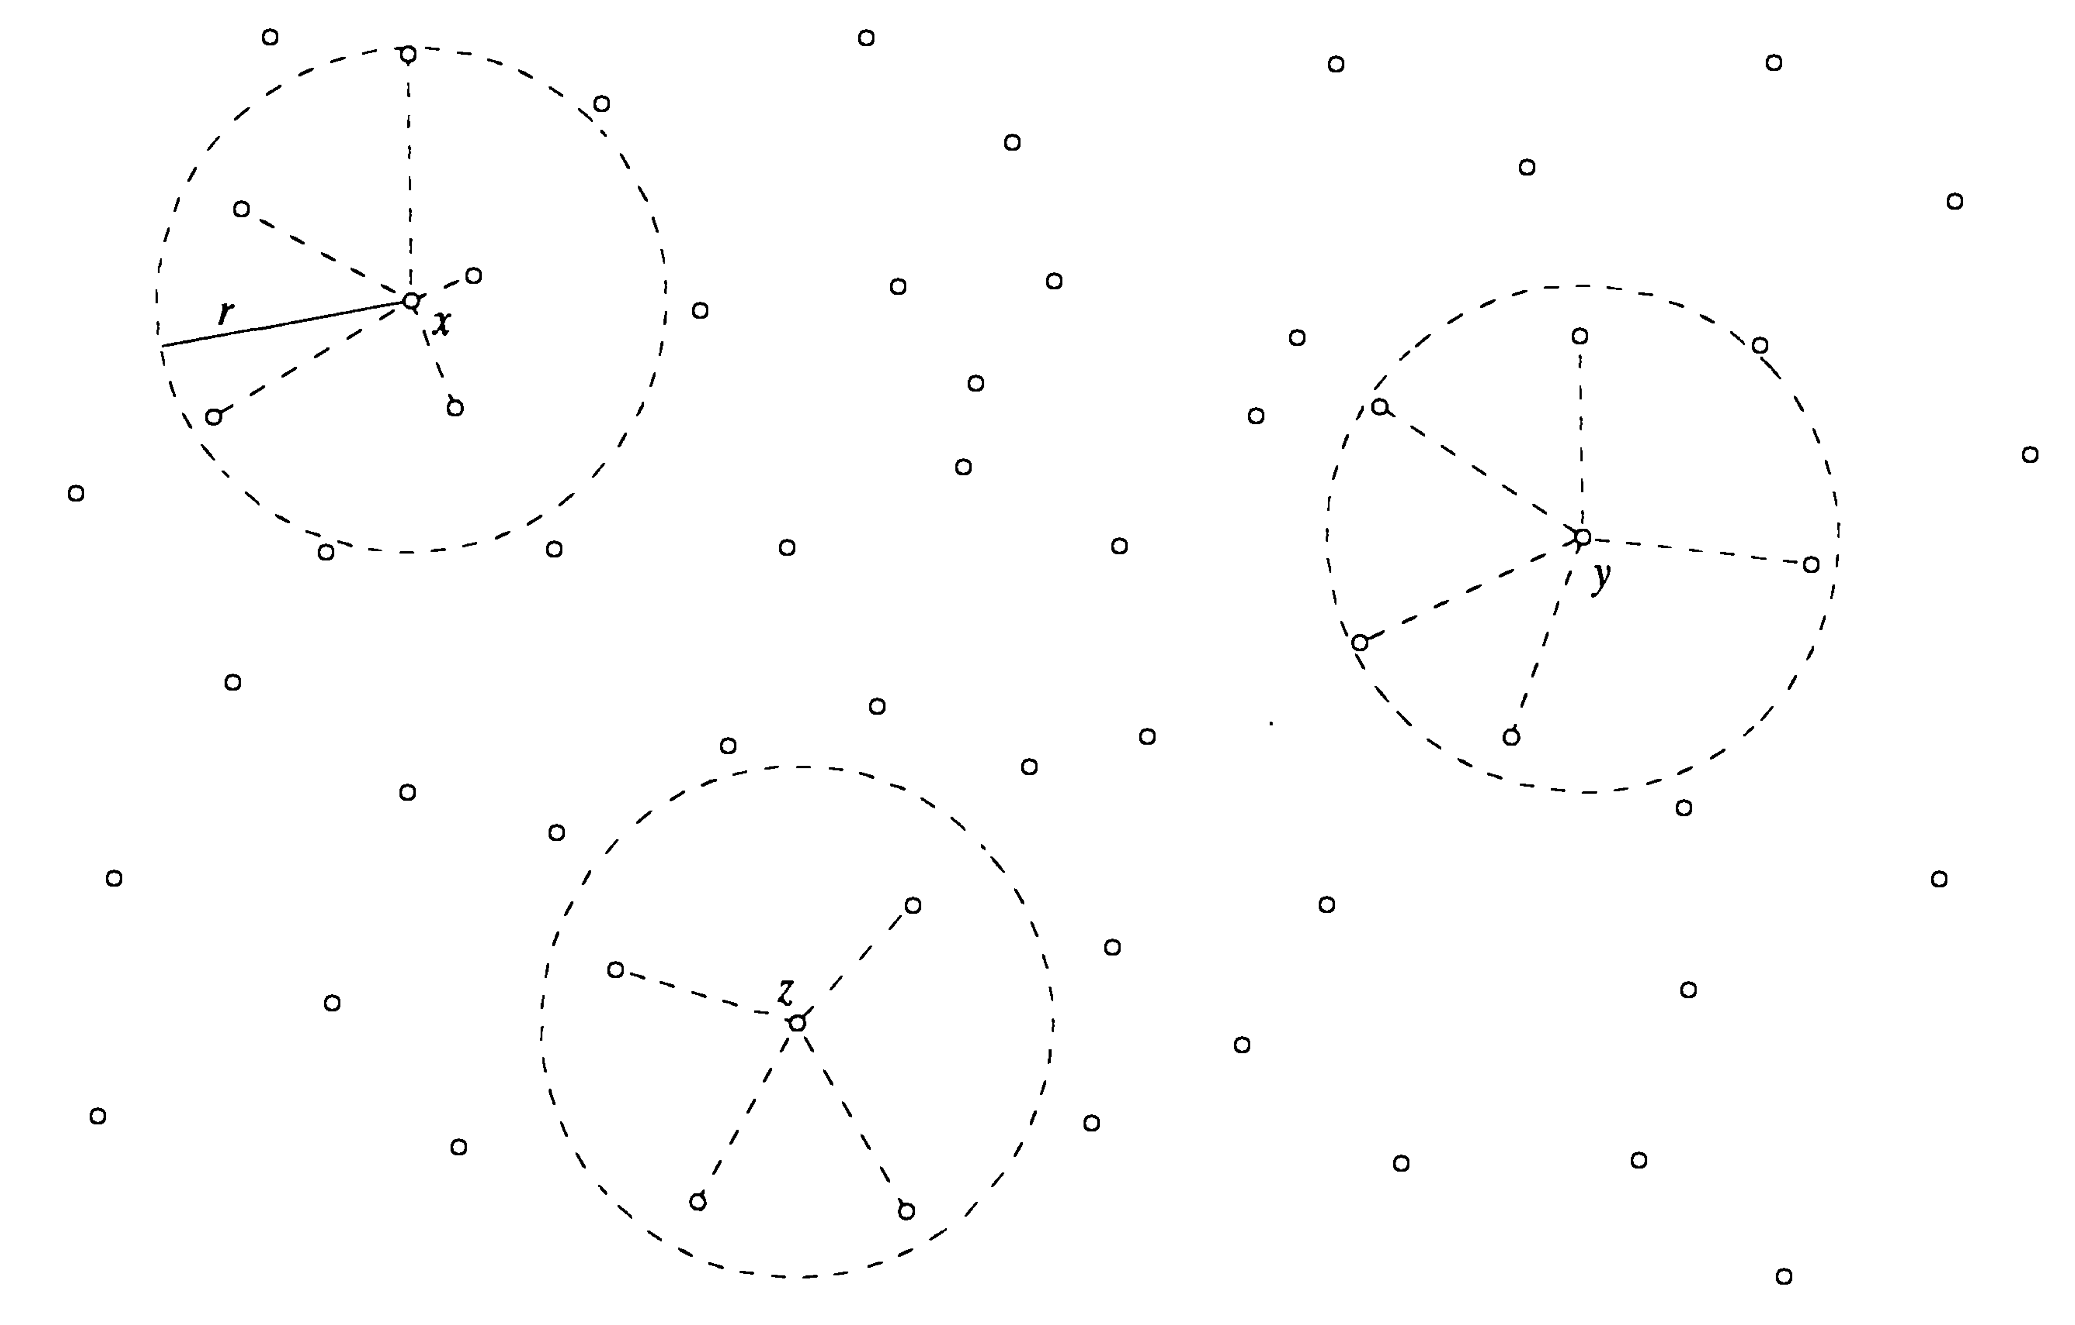

*Fig. 2. Three T-patches of an arbitrary Delone set.*

*Credit:* (Senechal, Quasicrystals and Geometry 1996)

A Delone set Λ is said to be a **regular** system of points if its T-patches are congruent for all r > 0 under rotation or reflection followed by rotation of $E^{n}$ (Senechal, Quasicrystals and Geometry 1996), and thus the following condition is satisfied:

$$∀\left(r>0\right)( T_{Λ}\left(x,r\right)≡ T_{Λ}\left(y,r\right) | x, y ∈Λ )$$

There is a local criterion for regularity imposed on an T-patch of a Delone set which guarantees the regularity of the entire point set. (J. Lagarias, Meyer's Concept of Quasicrystal and Quasiregular Sets 1996) This result is due to Delone et al. (1976)[29]:

**Local Criterion for Regularity**. Let Λ be a Delone set (r, R) in $R^{n}$. There exists a constant $m$ depending on the ratio $\frac{R}{r}$ and dimension *n* such that if the T-patches TΛ(*x*, *mR*) are congruent under rotation or reflection followed by rotation, then Λ is a regular point system.

# ttp://cnx.org/resources/1cfef86496bd1508b817b9bc2d5c7e23/graphics8.pngAppendix II. Bravais Lattices

Credit: (Barron and Smith 2010)

# Appendix III. Example of a Nonperiodic Tiling

Credit: (Gardner 1997)



A spiral nonperiodic tiling created by Heinz Vodeberg

with two enneagons as prototiles



A pair of enneagons forms an octagon tiling periodically.

Thus, the spiral tiling is not aperiodic.

# Appendix IV. Pinwheel Tiling

Credit: (Baake and Grimm, Aperiodic Order: Volume 1 , A Mathematical Invitation 2013)



*The inflation rule for the classic pinwheel tiling*

 The prototile is a right triangle with sides 1 and 2 and the hypotenuse $\sqrt{5}$, which is inflated by a factor of $\sqrt{5}$, then the image is dissected into 5 triangles congruent to the prototile and the process is repeated ad infinitum. The finite patch of the pinwheel tiling is given below:

# Bibliography

Ad Interim Commission on Aperiodic Crystals. "Report of the Executive Committee for 1991." *Acta Crystallographica Section A, Foundations of Crystallography* 48 (November 1992): 928.

Arnold, Vladimir Igorevich. *Huygens and Barrow, Newton and Hooke: Pioneers in mathematical analysis and catastrophe theory from evolvents to quasicrystals.* Moscow: Birkhäuser, 2004.

Ashcroft, Neil W., and N.David Mermin. *Solid State Physics.* Cornell University: Harcourt College Publishers, 1976.

Baake, Michael. "A Guide to Mathematical Quasicrystals." *arXiv*, January 1999: arXiv:math-ph/9901014.

Baake, Michael, and Uwe Grimm. *Aperiodic Order: Volume 1 , A Mathematical Invitation .* Cambridge: CUP, 2013.

Baake, Michael, and Uwe Grimm. "Kinematic diffraction from a mathematical viewpoint." *Zeitschrift für Kristallographie Crystalline Materials* 226, no. 9 (2011): 711–725.

Baake, Michael, and Uwe Grimm. "Mathematical diffraction of aperiodic structures ." *Chemical Society Reviews* 41 (2012): 6821-6843.

Baake, Michael, Robert V. Moody, and Martin Schlottmann. "Limit-(quasi)periodic point sets as quasicrystals with p-adic internal spaces ." *J. Phys. A: Math. Gen.*, 1998: 5755-5767.

Baake, Michael, Robert V. Moody, and Peter A.B. Pleasants. "Diffraction from visible lattice points and kth power free integers." *Discrete Mathematics* 221, no. 1-3 (2000): 3-42.

Barron, Andrew R., and Carrisa Smith. *Crystal Structure.* January 28, 2010. http://cnx.org/contents/e90d5161-66b0-4214-bd6c-9f1d20a35bae@10/Crystal_Structure (accessed March 1, 2015).

Besicovitch, Abram Samoilovitch. *Almost Periodic Functions.* Cambridge: CUP, 1954.

Bohr, Harald. *Almost Periodic Functions.* Chelsea: American Mathematical Society, 1947.

Catto, Isabelle, Claude Le Bris, and Pierre-Louis Lions. "Geometries which are not that non-periodic." In *Mathematical Theory of Thermodynamic Limits: Thomas-Fermi Type Models* , by Isabelle Catto, Claude Le Bris and Pierre-Louis Lions, 254-264. Paris: Oxford University Press, 1998.

Chapuis, Gervais, and Alla Arakcheeva. "The aperiodic nature of incommensurately modulated structures." *Rendiconti Lincei* 24, no. 1 (February 2013): 77-84.

De Bruijn, N. G. "Dualization of multigrids." *Le Journal de Physique Colloques*, 1986: C3:9-C3:18.

de Bruijn, N.G. "Algebraic theory of Penrose’s nonperiodic tilings of the plane." *Nederl. Akad. Wetensch. Indag. Math.* 43, no. 1 (1981): 39-52.

De Graef, Marc, and Michael E. McHenry. *Structure of Materials: An Introduction to Crystallography, Diffraction and Symmetry.* Carnegie Mellon University: CUP, 2012.

Delone, B.N, A.D Aleksandrov, and N.N Padurov. *Mathematical Foundations of the Structural Analysis of Crystals (in Russian).* Moscow-Leningrad: ONTI, 1934.

Delone, B.N., N.P. Dolbilin, M.I. Stogrin, and R.V. Galiulin. "A local criterion for regularity in a system of points ." *Sov. Math. Dokl 17*, 1976: 319-322.

Dolbilin, N.P. *Regular Systems (Introduction to Mathematical Crystallography) [in Russian].* Moscow: Znanie, 1978.

Dyson, Freeman. "Birds and Frogs." *Notices of the AMS* 56, no. 2 (2009): 212-223.

Encyclopedia of Mathematics. *Closure of a set.* November 9, 2014. http://www.encyclopediaofmath.org/index.php/Closure_of_a_set (accessed March 17, 2015).

—. *Connected space.* December 12, 2013. http://www.encyclopediaofmath.org/index.php/Connected_space (accessed March 17, 2015).

—. *Covering (of a set).* February 7, 2011. http://www.encyclopediaofmath.org/index.php?title=Covering_(of_a_set)&oldid=17687 (accessed March 4, 2015).

—. *Crystallographic group.* March 31, 2012. http://www.encyclopediaofmath.org/index.php?title=Crystallographic_group&oldid=24059 (accessed December 7, 2014).

—. *Dense set.* November 8, 2014. http://www.encyclopediaofmath.org/index.php/Dense_set (accessed March 16, 2015).

—. *Homeomorphism.* October 11, 2014. http://www.encyclopediaofmath.org/index.php/Homeomorphism (accessed March 17, 2015).

—. *Metric.* February 9, 2013. http://www.encyclopediaofmath.org/index.php?title=Metric&oldid=29410 (accessed March 5, 2015).

—. *Minkowski addition.* February 7, 2011. http://www.encyclopediaofmath.org/index.php/Minkowski_addition (accessed March 16, 2015).

Gahler, F., and J. Rhyner. "Equivalence of the generalised grid and projection methods for the construction of quasiperiodic tilings." *Journal of Physics A: Mathematical and General* 19, no. 2 (1985): 267-277.

Gardner, Martin. *Penrose Tiles to Trapdoor Ciphers: And the Return of Dr Matrix.* New York: MAA, 1997.

Goodman-Strauss, Chaim. "Aperiodic Hierarchical Tilings." *Foams, Emulsions, and Cellular Materials, Proceedings of NATO-ASI, E-354*, 1999: 481-496.

Goodman-Strauss, Chaim. "Matching Rules and Substitution Tilings." *Annals of Mathematics*, 1998: 181-223.

Grimm, Uwe, and Xinghua Deng. "Some comments on pinwheel tilings and their diffraction." *arXiv*, 2011: arXiv:1102.1750v1.

Grunbaum, Branko, and Geoffrey C. Shephard. *Tilings and Patterns.* New York: W.H. Freeman & Company, 1986.

Hof, A. "On diffraction by aperiodic structures." *Commun. Math. Phys.* 169 (1995): 25-43.

Janot, Christian. *Quasicrystals: A Primer.* Institut Laue-Langevin, Grenoble, France: OUP Oxford, 2012.

Kittel, Charles. *Introduction to Solid State Physics.* University of California, Berkeley: John Wiley & Sons, 2005.

Lagarias, J.C, and P.A.B Pleasants. "Repetitive Delone sets and quasicrystals ." *Ergodic Theory and Dynamical Systems*, 2003: 831-867.

Lagarias, J.C. "Geometric Models for Quasicrystals I. Delone Sets of Finite Type ." *Discrete Comput. Geom.*, 1999: 161-191.

Lagarias, J.C. "Mathematical quasicrystals and the problem of diffraction." In *Directions in Mathematical Quasicrystals*, by Michael Baake and Robert V. Moody, 61-95. Centre de Recherches Mathématiques Université de Montréal: AMS, 2000.

Lagarias, J.C. "Meyer's Concept of Quasicrystal and Quasiregular Sets ." *Communications in Mathematical Physics 179*, 1996: 365-376.

Lee, Jeong-Yup. "Substitution Delone sets with pure point spectrum are inter-model sets." *Journal of Geometry and Physics* 57, no. 11 (2007): 2263–2285.

Levine, Dov, and Paul J. Steinhardt. "Quasicrystals I. Definition and structure ." *Physical Review B* 34, no. 2 (July 1986): 596-616.

Levine, Dov, and Paul J. Steinhardt. "Quasicrystals: A New Class of Ordered Structures." *Phys. Rev. Lett.* 53, no. 26 (1984): 2477-2480.

Lifshitz, Ron. "Quasicrystals: A matter of definition." *Foundations of Physics*, December 2003: 1703-1711.

Lifshitz, Ron. "What is a crystal?" *Condensed Matter Physics*, 2007: 114-36.

Meyer, Yves. *Algebraic numbers and harmonic analysis.* France: North-Holland, 1972.

Moody, Robert V. *Long-range order and diffraction.* Proceedings of a Conference on Groups and Lie Algebras, Tokyo: Sophia Kokyuroku in Mathematics, 2006.

Moody, Robert V. "Meyer sets and their duals." In *Mathematics of Long Range Aperiodic Order* , by Robert V. Moody, -. Nato Science Series C: Springer Netherlands, 1997.

Moody, Robert V. "Model Sets: A Survey." In *From Quasicrystals to More Complex Systems*, by Françoise Axel, Françoise Dénoyer and Jean-Pierre Gazeau, 145-166. Les Houches School: Springer Berlin Heidelberg, 2000.

Moody, Robert V. "Review: Aperiodic Order, Vol. 1, A Mathematical Invitation by Michael Baake and UWE Grimm." *The Mathematical Intelligencer*, March 2015: 89-92.

Niven, Ivan. *Numbers: Rational and Irrational.* University of Oregon: Mathematical Association of America, 1961.

Phillips, Tony. *X-ray Crystallography and the Fourier Transform.* October 10, 2011. http://www.ams.org/samplings/feature-column/fc-2011-10 (accessed March 26, 2015).

Radin, Charles. "The Pinwheel Tilings of the Plane." *Annals of Mathematics* 139, no. 3 (May 1994): 661-702 .

Schlottmann, Martin. "Cut-and-project sets in locally compact abelian groups." In *Quasicrystals and Discrete Geometry*, by J. Patera, 247-264. Providence: AMS, 1998.

Schlottmann, Martin. "Periodic and Quasi-Periodic Laguerre Tilings." *International Journal of Modern Physics B* 7 (1993): 1351-1363.

Seeger, Andreas. *NOTES ON ANALYSIS II: CHARACTERIZATIONS OF COMPACTNESS FOR METRIC SPACES.* April 10, 2013. https://www.math.wisc.edu/~seeger/522/c13.pdf (accessed March 16, 2015).

Senechal, Marjorie. "Mapping the aperiodic landscape, 1982–2007." *Philosophical Magazine* 88 (2008): 1-21.

—. *Quasicrystals and Geometry.* Northampton: Cambridge University Press, 1996.

Senechal, Marjorie. "What is a Quasicrystal?" *NOTICES OF THE AMS* 53, no. 8 (September 2006): 886-887.

Shechtman, D., I. Blech, D Gratias, and J.W Cahn. " Metallic phase with long-range orientational order and no translational symmetry." *Phys. Rev. Lett.*, 1984: 1951-1953.

Strungaru, Nicolae. "Almost Periodic Measures and Meyer Sets." *arXiv*, 2015: arXiv:1501.00945.

Sólyom, Jenö. *Fundamentals of the Physics of Solids: Volume 1: Structure and Dynamics.* Translated by Attila Piróth. Research Institute for Solid State Physics and Optics: Springer, 2010.

The International Union of Crystallography. *Aperiodic crystal.* February 3, 2012. http://reference.iucr.org/dictionary/Aperiodic_crystal (accessed February 3, 2015).

—. *Incommensurate composite crystal.* February 6, 2012. http://reference.iucr.org/dictionary/Incommensurate_composite_crystal (accessed January 7, 2015).

—. *Noncrystallographic symmetry.* November 6, 2013. http://reference.iucr.org/dictionary/Noncrystallographic_symmetry (accessed January 8, 2015).

—. *Primitive Cell.* May 21, 2008. http://reference.iucr.org/dictionary/Primitive_cell (accessed December 4, 2014).

—. *Wigner-Seitz Cell.* February 8, 2012. http://reference.iucr.org/dictionary/Wigner-Seitz_cell (accessed December 6, 2014).

Tilley, Richard J. D. *Crystals and Crystal Structures.* University of Cardiff: John Wiley & Sons, 2006.

Weisstein, Eric W. *Bounded Set.* March 15, 2015. http://mathworld.wolfram.com/BoundedSet.html (accessed March 15, 2015).

—. *Closed Set.* September 4, 2015. http://mathworld.wolfram.com/ClosedSet.html (accessed March 6, 2015).

—. *Countably Infinite.* March 2, 2015. http://mathworld.wolfram.com/CountablyInfinite.html (accessed March 15, 2015).

—. *CRC Concise Encyclopedia of Mathematics CD-ROM.* US: CRC Press, 2002.

—. *Orthonormal Basis.* March 2, 2015. http://mathworld.wolfram.com/OrthonormalBasis.html (accessed March 13, 2015).

—. *Smooth Function.* March 14, 2015. http://mathworld.wolfram.com/SmoothFunction.html (accessed March 14, 2015).

1. The closure of a set A is the intersection of all closed sets of X containing the set A. (Encyclopedia of Mathematics 2014)
2. , form a subset of the Euclidean space, which contains mutually perpendicular unit vectors. The linearly independent elements of the orthonormal basis span the vector space $E^{n}$. (Weisstein 2015)
3. A set is countably infinite if it can be put into one-to-one correspondence with the natural numbers. (Weisstein, Countably Infinite 2015)
4. The orbit of a point group is the set of all permutations of points resulting from the group action.
5. Note that Bravais lattices described in Section I.1 are three-dimensional point lattices.
6. A *closed set S* is a set such that every point outside S has a neighbourhood disjoint from S. (Weisstein, Closed Set 2015)
7. *M* usually denotes a transformation group, although other restrictions can be also imposed (e.g., tile colouring).
8. A locally finite tiling *T* is a tilingsuch that for all $x∈R^{n}, r>0$*B(x,r)* intersects a finite number of tiles in *T*.
9. *Homeomorphism* is a one-to-one correspondence between two topological spaces such that the two mutually inverse mappings defined by this correspondence are continuous. (Encyclopedia of Mathematics, Homeomorphism 2014) If a prototile is homeomorphic to an n-ball, intuitively it can be continuously deformed into the n-ball, and vice versa.
10. A *connected* set is a subset of a topological space which cannot be represented as the union of two non-empty disjoint both open and closed sets. (Encyclopedia of Mathematics, Connected space 2013)
11. Note that the Wigner-Seitz cell of a three-dimensional lattice by definition is a Voronoi domain in three dimensions.
12. denotes all finite integer linear combinations of the set X.
13. An abelian group [X] is *finitely generated* if there exists a set of elements

 $S=x_{1}, x_{2}, x_{3},…, x_{n},S⊆\left[X\right]$   , such that each element $x∈[X]$ is defined uniquely by the sum of the integer multiples of the S elements: $x=\sum_{i=1}^{n}{a_{i}x_{i}},$ where $a_{i}∈Z.$

    S is called a *generating set* of [X].
14. Cf. Appendix I.II
15. stands for the supremum of a set S, which is defined as the least upper bound M of the set such that no element of S exceeds M, but for any $ε>0$ there is an element of S exceeding M $- ε$. (Weisstein, CRC Concise Encyclopedia of Mathematics CD-ROM 2002)
16. A function $f$ is called diagonal if $f$ is a map of a set X to the n-fold Cartesian product set Xn, i.e. .
17. The *commensurate* values are related in the following sense (Niven 1961). If there exists some integer *k* such that the first value under consideration can be divided into *k* equal parts *l*, the second value can be measured in the integer number m of these lengths *l*, and the ratio of the values is

    kl/ml=k/m,

    which is a rational number. If the ratio of two values, e.g. periods, is irrational, there is no integer such that the aforementioned comparison can be performed. Hence, these two values are said to be *incommensurate*.
18. A function $f$ is smooth over a restricted interval if it has continuous derivatives over the restricted domain. (Weisstein, Smooth Function 2015)
19. A set S in a metric space with the metric *d* is *bounded* if there is a finite R for all $x, y∈S$ such that $d\left(x,y\right)≤R$. (Weisstein, Bounded Set 2015)
20. A set $Λ-Λ$ can be intuitively understood as a set of distances between the individual points of Λ.
21. Let X be a metric space with the metric d. A family of open sets ${\left\{G_{α}\right\}}_{α∈A}$ with the index set A is called an *open cover* of X if every $x∈X$ belongs to at least one of the $G_{α}, α∈A$. An open cover is *finite* if the index set $A$ is finite. A subset $X^{'}⊆X$ with the inherited metric is **compact**if every open cover of $X'$ contains a finite subcover. A subset $X^{'}⊆X$ is **relatively compact** if the closure $\overline{X'}⊂X$ is a compact subset of X. (Seeger 2013)
22. A subset S of a topological space X is *dense* if it intersects every nonempty open subset of X. (Encyclopedia of Mathematics 2014)
23. If G is a topological group, G is *locally compact* if for all $x∈G$ $x$ has a compact neighbourhood. If G is also abelian, it is an *abelian locally compact group.* (Baake and Grimm, Aperiodic Order: Volume 1 , A Mathematical Invitation 2013)
24. A square matrix $A=(a_{ij})$ is *primitive* if all entries are nonnegative and there exists *k* such that for all $i,j$ the $(i, j)$ entry of $A^{k}$ is positive.
25. Two tilings *T* and *T’* of $R^{n}$ are *dual* if there exists a bijective map between the k-dimensional subspaces of *T* and the (n-k)-dimensional subspaces of *T’, $k∈\{0\}∪N$* . Two tilings are *orthogonally dual* if, for $k>0$, the corresponding subspaces of dimension *k* and *(n–k)* are orthogonal. (Senechal, Quasicrystals and Geometry 1996)
26. A *hyperplane* in $R^{n}$ is a vector subspace of dimension .
27. There is no energy transfer between the scattered beam and the atom.
28. A set S in a metric space is *open* if every point in S has a neighbourhood belonging to S. (Weisstein, CRC Concise Encyclopedia of Mathematics CD-ROM 2002)
29. (Delone, et al. 1976)